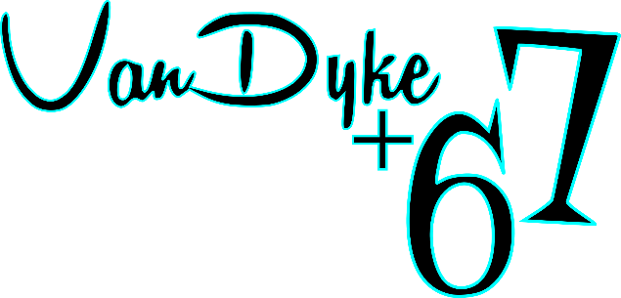

**Barber Grant Application**

Name: Click or tap here to enter text. Email: Click or tap here to enter text.

Phone: Click or tap here to enter text. Graduation Date: Click or tap here to enter text.

An in-person interview at VanDyke+67 will be required for shortlisted listed individuals. (flexible scheduling will be available) Do you commit attending to the in-person interview?  Yes  No

Tell us about your prior barbering, career or life experiences:

Click or tap here to enter text.

How will you embrace the 50’s machine shop/racing theme in your business?

Click or tap here to enter text.

We expect a barber, coffee shop, potential pop up shops and a restaurant or brewery to share a large open space and complement one another. How will you contribute to this team?

Click or tap here to enter text.

A five year lease will be signed after a brief trial period. Will you commit to this timeframe?

Yes  No

Will you live in Marlette and participate with our community?  Yes  No

Why do you deserve this opportunity?

Click or tap here to enter text.

Send a video of yourself describing your passions in life, how you work, your dreams, and your ideas about the theme and your new barbering space – or anything else you want us to know about you! (This is a great way to show us what you’ve got and showcase your marketing, technology and communication skills)

Submit application and all supporting information via email only to [VanDyke67@gmail.com](mailto:VanDyke67@gmail.com?subject=Barber%20Application)